WEEK 6 – GIT
Submitted By: Priyanshu Shekhar
Superset ID: 8011160
College: C. V. Raman Global University, Odisha
Registration No.: 2301020267
Email: shekharpriyanshu21@gmail.com

Please follow the instructions to complete the hands-on. Each instruction expect a command for the Git Bash.
- Verify if master is in clean state.
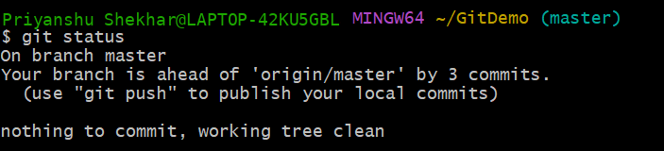
- Create a branch “GitWork”. Add a file “hello.xml”.
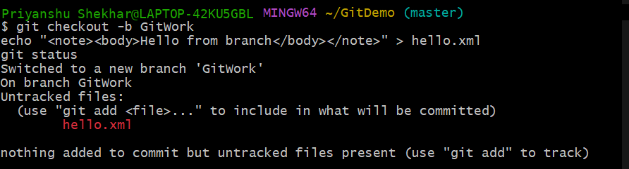
- Update the content of “hello.xml” and observe the status
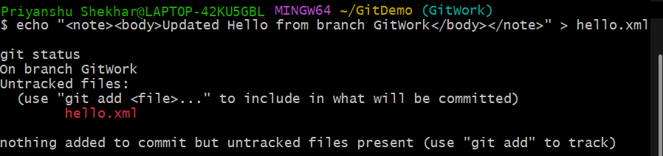

- Commit the changes to reflect in the branch
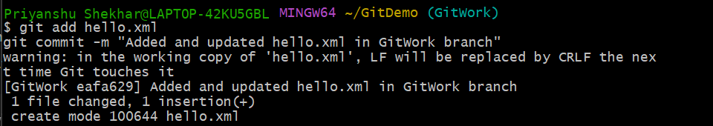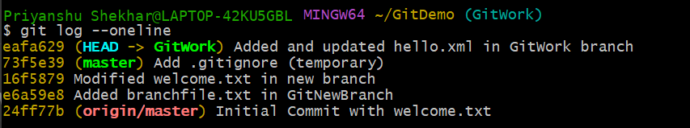
- Switch to master.
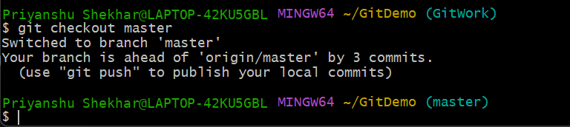
- Add a file “hello.xml” to the master and add some different content than previous.
- Commit the changes to the master

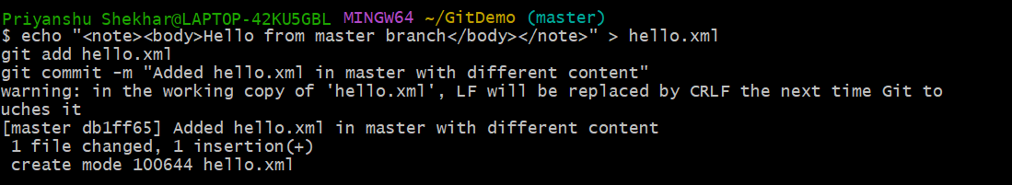

- Observe the log by executing “git log –oneline –graph –decorate –all”
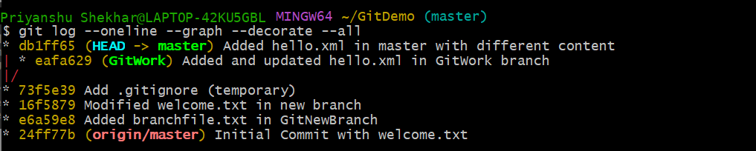

- Check the differences with Git diff tool
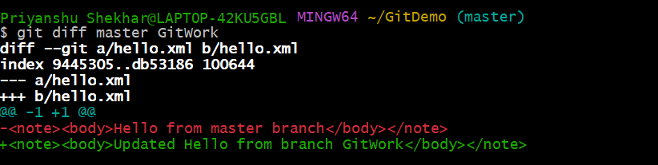
- For better visualization, use P4Merge tool to list out all the differences between master and branch
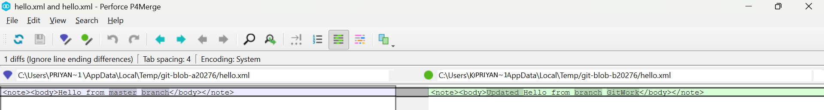
- Merge the bran to the master

- Observe the git mark up.

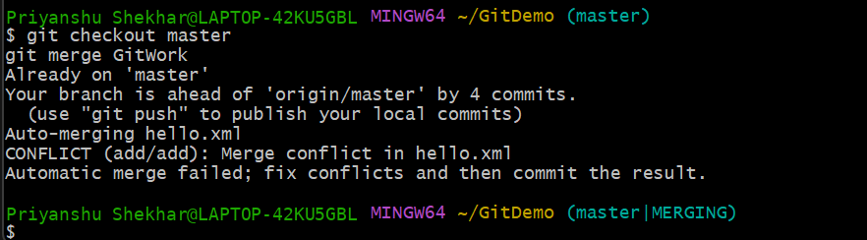
- Use 3-way merge tool to resolve the conflict
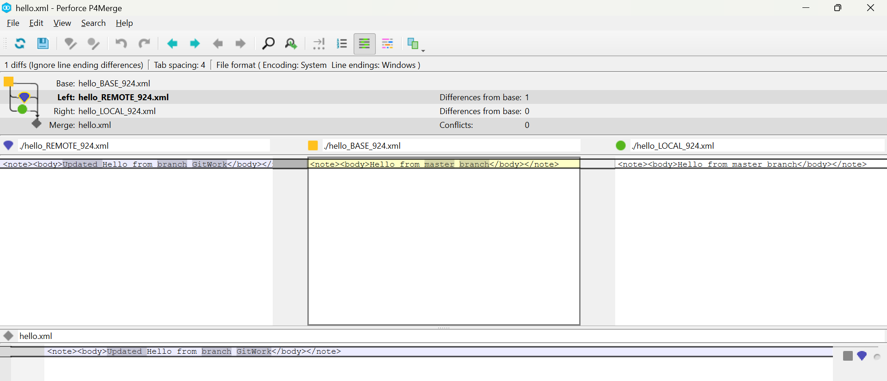

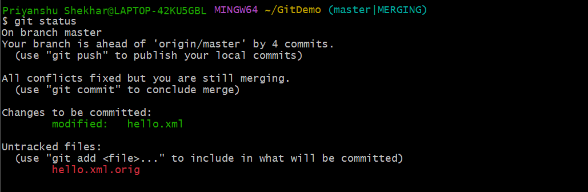
- Commit the changes to the master, once done with conflict
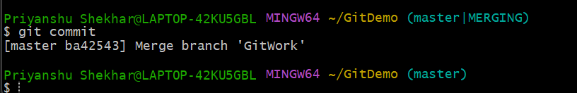
- Observe the git status and add backup file to the .gitignore file.

- Commit the changes to the .gitignore

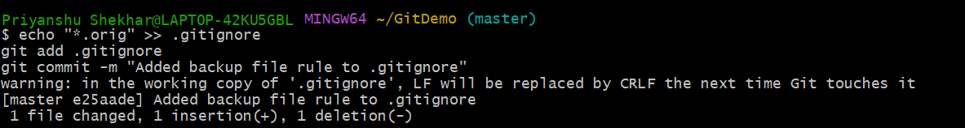
- List out all the available branches

- Delete the branch, which merge to master.

- Observe the log by executing “git log –oneline –graph –decorate”

